**A. Cover Page**

**1. Project Title**

**Expanding the California Fertilization guidelines to support nutrient management decisions for minor annual crops**

**2. Project Leader**

*Daniel Geisseler*, CE Nutrient Management Specialist, University of California, Department of Land, Air and Water Resources, One Shields Ave., Davis, CA, 95616. (530) 754 9637, djgeisseler@ucdavis.edu

**2. Supporter**

*Casey Creamer*, Southern San Joaquin Valley MPEP Committee, 4886 E. Jensen Avenue, Fresno, CA, 93725. (559) 237-5567, ccreamer@krcd.org

**3. CDFA Funding Request Amount/Other Funding**

|  |  |  |
| --- | --- | --- |
|  | **CDFA Funding Request** | **Other Funding** |
| 01/01/2017-06/30/2017: | $ 18,799 | $ 0 |
| 07/01/2017-06/30/2018: | $ 94,962 | $ 0 |
| **Total:** | **$ 113,761** | **$ 0** |

**4. Agreement Manager**

*Ahmad Hakim-Elahi*, Executive Director, Office of Research. 1850 Research Park Drive, Suite 300, Davis, CA 95618-6153. (530) 754 7687, [awards@ucdavis.edu](mailto:awards@ucdavis.edu)

**B. Executive Summary**

**1. Problem**

California growers are facing increasing pressure to improve nitrogen (N) use efficiency in crop production to reduce nitrate leaching to the groundwater. For many crops, a comprehensive overview and synthesis of the current research on fertilizer use and management has long been missing. With support from FREP (projects 11-0485-SA and 15-0231), we have been closing this gap by writing online fertilization guidelines for about two dozen major crops grown in California.

While the crops featured on the website are grown on a large proportion of California's cropland, growers in the state produce a variety of other crops. For many smaller-acreage crops, very little information on nutrient management under California's conditions is currently available, which makes writing crop-specific guidelines relevant for California a challenging task.

However, by reviewing the relevant literature for all these crops over the last few years, we have gained a very good overview and understanding of practices that ensure efficient use of fertilizer under California conditions. Many of these practices not only depend on the kind of crop grown, but also on the cropping system, climatic conditions, and soil type. Furthermore, in an ongoing project we are currently compiling the available literature to create a database of N removed at harvest for most California crops. When combining general practices with crop-specific information, such as N removed at harvest, total N uptake and growth stage when harvested, management practices that ensure high N use efficiency can be identified and described.

**2. Objectives, Approach, and Evaluation**

*Objectives*

The objectives of this proposal are (i) to provide growers and crop advisers with information about nutrient management for annual crops about which insufficient information is available for detailed crop-specific guidelines and (ii) to create an educational tool to highlight the effect of major factors that determine N use efficiency in the field, such as irrigation management, soil type, root system, and the interactions between these factors.

*Approach*

The objectives will be achieved by adding two new components to the online fertilization guidelines:

1. We will create a generalized nutrient management web page discussing efficient nutrient management practices that uses the same user-friendly, interactive format as the existing crop-specific guidelines. This page shall highlight important points that need to be considered when making nutrient management decisions. Topics will include the 4R's of nutrient management, (right rate, right time, right source and right place) soil test interpretation and plant tissue test interpretation. For soil and plant tissue tests, the focus will be on how they can be used in the absence of crop-specific critical values. General information on deficiency symptoms will also be included. As is the case with the existing crop-specific guidelines, the discussion will cover N, phosphorus (P) and potassium (K).
2. We will create a simple N calculator, based on crop N uptake, N removal at harvest, and estimated irrigation system efficiency. The N calculator will provide growers with estimates of N requirements and timing of N uptake for a wide range of annual crops. We expect to include at least 20 additional crops. Embedded in the N calculator we will create an N budget tool that shall allow users to explore the effects of irrigation management, soil type and root system on N use efficiency. The data currently available from California does not allow for the calculation of accurate and robust site-specific N budgets. For this reason, the N budget tool will be designed as an educational tool that shall help users better understand the factors affecting N use efficiency and how these factors interact. A major focus of this part of the tool shall be on the interaction between irrigation and N management. An effort will be made to visualize these interactions.

*Evaluation*

Use of the web pages will be monitored using Google-Analytics. Since January 2015, the crop-specific guidelines have generated more than 400 page views on average per month. We expect that the number of users will increase by 20% annually. The guidelines will be presented at different of meetings and conferences. We expect to reach at least 150 people with presentations through 2018. Feedback from the audience and users shall be used to increase the usefulness of the site and improve its content.

**3. Audience**

The primary audience of the online guidelines and the proposed additions are growers and crop advisers. The website is also a valuable resource for college students taking classes in agronomy or nutrient management. In addition, potential users include industry, government agencies and other entities.

**C. Justification**

**1. Problem**

California growers are facing increasing pressure to improve nitrogen (N) use efficiency in crop production to reduce nitrate leaching to the groundwater. For many crops, a comprehensive overview and synthesis of the current research on fertilizer use and management has long been missing. With support from FREP (projects 11-0485-SA and 15-0231), we have been closing this gap by writing fertilization guidelines for major crops grown in California. Currently, guidelines for 23 crops are available online in a user-friendly, interactive format (<https://apps1.cdfa.ca.gov/FertilizerResearch/docs/Guidelines.html>). By summer 2017, guidelines for at least 28 crops will be online.

The California Fertilization Guidelines have become an important resource for growers and crop advisers who need nutrient management related information for a variety of crops. Since January 2015, they have generated on average more than 400 page views per month. The guidelines have been highlighted as a resource at the N management training for Certified Crop Advisers and the self-certification training for growers. With regulatory pressure increasing, the need for research-based information on crop management will likely increase their popularity in the future.

While the crops featured on the website are grown on a large proportion of California's cropland, growers in the state produce a variety of other crops. The California Agricultural Statistics Review 2014-2015 (CDFA, 2016), lists approximately 80 crops that are grown in California, a majority of them being annual crops. While it may be argued that these smaller-acreage crops have little effect on the overall quality of groundwater in California, nutrient management decision made for these crops may affect the quality of local aquifers and wells. Furthermore, growers need research-based information for the crops they grow, independent of the total acreage in California.

For many of these minor crops, very little information on nutrient management under California's conditions is currently available, which makes writing crop-specific guidelines relevant for California a challenging task.

However, by reviewing the relevant literature for more than two dozen crops over the last few years, we have gained a very good overview and understanding of practices that ensure efficient use of fertilizer under California conditions. Many of these practices not only depend on the kind of crop grown, but also on the cropping system, crop management, climatic conditions, and soil type. When combined with crop-specific information, such as N removed at harvest, total N uptake and growth stage when harvested, management practices that ensure high N use efficiency can be identified and described. We are currently compiling the available literature to create a database of N removed at harvest by most crops grown in the Central Valley, and so have already collected some of the relevant information.

The objectives of the proposed project are (i) to provide growers and crop advisers with information about nutrient management for at least 20 additional crops for which insufficient information is available for detailed crop-specific guidelines and (ii) to create an educational tool to highlight the effect of major factors that determine N use efficiency in the field, such as irrigation management, soil type, root system, and the interactions between these factors.

The objectives will be achieved by adding three new components to website: (i) A discussion of general principles of efficient nutrient management practices for cropping systems in California. These principles will be presented in the same format as the existing crop-specific guidelines; (ii) a crop-specific N calculator. The calculator will be designed as an interactive tool allowing users to estimate total N requirement of their crops (fertilizer and non-fertilizer N) based on their own yield goal and irrigation system (Figure 1). A seasonal N uptake curve shall also be generated. (iii) Embedded in the N calculator we will create an N budget tool, which will provide estimates of the amount of N fertilizer required based on soil type, N in irrigation water, residual soil nitrate and climatic conditions (Figure 2). The budget tool will rely on some assumptions for which detailed data from California is not yet available. For this reason, the tool will be designed as an educational tool that highlights the factors affecting N use efficiency and that lets users explore the effects of different management practices and environmental conditions.

**2. FREP Mission and Research Priorities**

The proposed project addresses the FREP Special Request for Proposals 2016 Focus Area “***Education and Outreach*”. The proposed project builds on the online fertilization guidelines which have been developed with FREP support.**

**3. Impact**

The guidelines are the most comprehensive source of crop-specific information about nutrient management for crops grown in California. They are a valuable source of information for growers and crop advisers and are freely available online. With the proposed additions, the number of crops, for which nutrient management information is provided, will increase considerably. The additions will be especially valuable, because little to no information is currently publicly available for many of these crops.

Using these resources will help growers and crop advisers plan their nutrient management, improve N fertilizer use efficiency and reduce the risk of nitrate leaching.

The proposed additions will also be highly valuable for presentations (e.g. N management training refresher for CCA and self-certifying growers) and agronomy and nutrient management classes at colleges and universities.

**4. Long-Term Solutions**

The proposed additions to the guidelines will be freely available online and can be used on a desktop computer and mobile devices. Compared to textbooks and brochures, online publication facilitates updating the content and incorporating new findings, thus ensuring their usefulness in the long-term.

The proposed additions will improve the impact of the guidelines, supporting growers and crop advisors to make informed nutrient management decisions about a wider variety of crops, increasing N use efficiency in their production and resulting in lower risks of nitrate leaching to the groundwater. The new components provide users with background information that help them better understand the processes and factors affecting nutrient use efficiency in the field, allowing them to make educated decisions in the absence of detailed guidelines or recommendations.

**5. Related Research**

The proposed project builds on several completed and ongoing projects:

*Fertilization guidelines*

With support from FREP (projects 11-0485-SA and 15-0231), results from research projects, including many FREP-funded studies, have been synthesized to create web-based fertilization guidelines for specific crops. The guidelines present accurate and timely crop nutrient information in a user-friendly, visually interactive interface. They include information about application rates, time of application, fertilizer placement and types of fertilizers. The guidelines provide information about N, P, and K management. In addition, they describe deficiency symptoms, discuss the use of soil and plant tissue analysis, and provide instructions for representative sampling. An extensive list of references and links to sites with additional information complement the guidelines. By summer 2017, guidelines for at least 28 crops will be freely available online (<https://apps1.cdfa.ca.gov/FertilizerResearch/docs/Guidelines.html>).

The guidelines are the most comprehensive source of crop-specific information about nutrient management for crops grown in California. The proposed project aims expand the content of the website.

The insight and understanding gained by summarizing the literature for all these crops will help provide information that is useful for a wide range of annual crops.

We will use the existing crop-specific guidelines as a template for the discussion of the principles of efficient nutrient management, minimizing the time required for web development for this part of the project.

*Report on N removal rates for crops grown in the Central Valley*

In an ongoing project we are currently compiling the available literature to create a database of N removed at harvest. The project is funded by the Kings River Watershed Coalition. When completed by the end of 2016, N removal rates (on a lbs N per unit yield basis) will be available for crops that cumulatively cover 99% of the acreage in the Central Valley.

While not part of the project, scientific papers and reports that provide information on N removal rates also include data on total crop N uptake. Both N removal and total uptake will be needed to calculate N requirement based on growers' target yield. Knowing these papers will greatly reduce the time needed to compile N uptake data for smaller-acreage crops for the proposed project.

*N mineralization in California soils*

In an ongoing project supported by UC ANR, we are investigating the N mineralization rate of agricultural soils from different regions of California and the effect of soil properties and temperature on the amount of N mineralized. To minimize the effects of sample handling, the study is carried out with undisturbed soil cores. By fall 2017 we expect to have the results from more than 60 agricultural soils from across California. The results of this study will provide information for the site-specific N mineralization rates for the N budget tool.

*Review articles on soil testing*

We have recently published a review article in California Agriculture about soil test interpretation (Geisseler and Miyao, 2016). A second article discussing soil nitrate analyses has been accepted and will be published soon (Lazicki and Geisseler, accepted). Both focus on irrigated cropping systems typical for California. Our discussion on soil N testing in the proposed additions will draw from these two peer-reviewed articles and the literature used to write them.

**6. Contribution to Knowledge Base**

The guidelines, together with the proposed additions, will be the most comprehensive source of crop-specific information about nutrient management for crops grown in California. A large proportion of the information summarized on the website is from publications that are not available online and from scientific articles published in journals which require subscription. Therefore, the site summarizes information to which most growers and crop advisers do not otherwise have access. With the proposed additions, we will close an important knowledge gap, by providing information for crops for which little research has been done and no specific guidelines are available.

**7. Grower Use**

The proposed additions to the guidelines will be freely available online. They will be easy to navigate and written in a clear and concise way intended for a non-scientific audience. The design of the web pages will be responsive, which means that it will automatically adjust to the screen width of the users' device, optimizing the users' experience.

**D. Objectives**

The objectives of this proposal are (i) to provide growers and crop advisers with information about nutrient management for crops for which insufficient information is available for detailed crop-specific guidelines and (ii) to create an educational tool to highlight the effect of major factors that determine N use efficiency in the field. The specific objectives are:

1. Create a webpage discussing the principles of efficient nutrient management practices for cropping systems in California.
2. Design crop-specific online N calculator.
3. Within the N calculator, create an N budget tool that allows users to explore the effects of crop characteristics, soil type and irrigation management on N use efficiency.
4. Write final report.

**E. Work Plans and Methods**

**1. Work Plan**

The objectives shall be met by completing the following tasks by June 30, 2018:

Task 1: Summarize principles of efficient nutrient management in California's cropping systems

By reviewing the relevant literature for more than two dozen crops over the last few years, we have gained a very good overview and understanding of practices that ensure efficient use of fertilizer under California conditions.

The principles of efficient nutrient management shall be discussed on a website that has the same design as the existing guidelines for specific crops. The web page shall include information on the 4 R's of N, P and K management (right rate, right time, right source and right place), soil test interpretation, and ways to use plant tissue analysis in the absence of reliable critical values. General symptoms of nutrient deficiencies shall also be included.

In contrast to textbooks, this webpage will focus on practices specific to cropping systems and environmental conditions in California. It will be freely available online in a user friendly way and written for a non-scientific audience. Furthermore, the page will be linked to an interactive tool, the N calculator, which allows estimating optimal N application rates based on user input (see below).

Task 2: Develop crop-specific N calculator

Application rate and optimal time of application heavily depend on crop species, yield, and crop management. These factors will be taken into account in the N calculator.

Growers will be able to enter basic information about their crop and the cropping system, such as crop type, yield goal, and irrigation system. The calculator will then estimate the total amount of N required (fertilizer N and non-fertilizer N) to achieve the target yield. The calculation will be based on data about crop removal at harvest and total N uptake (Figure 1). With a grant from the Kings River Watershed Coalition, we are currently compiling the information on N removal with harvested plant parts (see Related Research). While not part of the project, many papers reporting N removal rates also contain information on total crop N uptake. Knowing these papers will greatly reduce the time needed to compile N uptake data for smaller-acreage crops for the proposed project. Combined with an estimate of the irrigation system efficiency, the amount of available N required by the crop can be estimated. This approach is similar to the budgeting approach used for tree crops.

Optimal time of application depends on the seasonal N uptake curve. An N uptake curve may not be available for many smaller-acreage crops. In the absence of a published curve, the N calculator will create an uptake curve based on total N uptake and N removed with harvested crops. In general, the N uptake curve is S-shaped for annual plants, with the N uptake rate being low during germination and seedling growth, reaching a maximum during vegetative growth and slowing down during generative growth. The calculator will modify the shape of the curve depending on whether the crop is seeded or transplanted, the growth stage the crop is harvested (during vegetative growth or at maturity), and on the crops growth pattern (indeterminate or determinate). We expect to develop crop specific N calculators for at least 20 crops. Based on a preliminary analysis of the available data, the 20 crops listed in Table 1, belonging to different botanical families, appear to be good candidates for inclusion.

**Table 1:** Preliminary list of crops that will be included (values are in harvested acres in California based on the USDA 2012 Census available at: <https://quickstats.nass.usda.gov/>).

|  |  |
| --- | --- |
| **Amaranthaceae (amarantts)** | **Poaceae (grasses)** |
| Beet (beetroot; 2,700 acres) | Durum wheat for grain (135,500 acres) |
| Sugar beets (27,200 acres) | Oats for grain (25,100 acres) |
| **Brassicaceae** (**crucifers)** | Rye for grain (1,800 acres) |
| Cabbage (9,800 acres) | Small grain for hay (370,700 acres) |
| **Convolvulaceae** (**morning glory**) | Sorghum for grain (13,900 acres) |
| Sweet potatoes (18,200 acres) | Sweet corn (32,700 acres) |
| **Cucurbitaceae (gourds)** | Triticale for grain (14,700 acres) |
| Cucumbers (7,900 acres) | **Solanaceae (nightshades)** |
| Pumpkin (6,200 acres) | Bell pepper (19,200 acres) |
| Squash (7,800 acres) | Chile peppers (7,000 acres) |
| Watermelon (13,400 acres) | Eggplant (1,200 acres) |
| Zucchini (included in the acreage for squash) | Fresh market tomatoes (39,200 acres) |

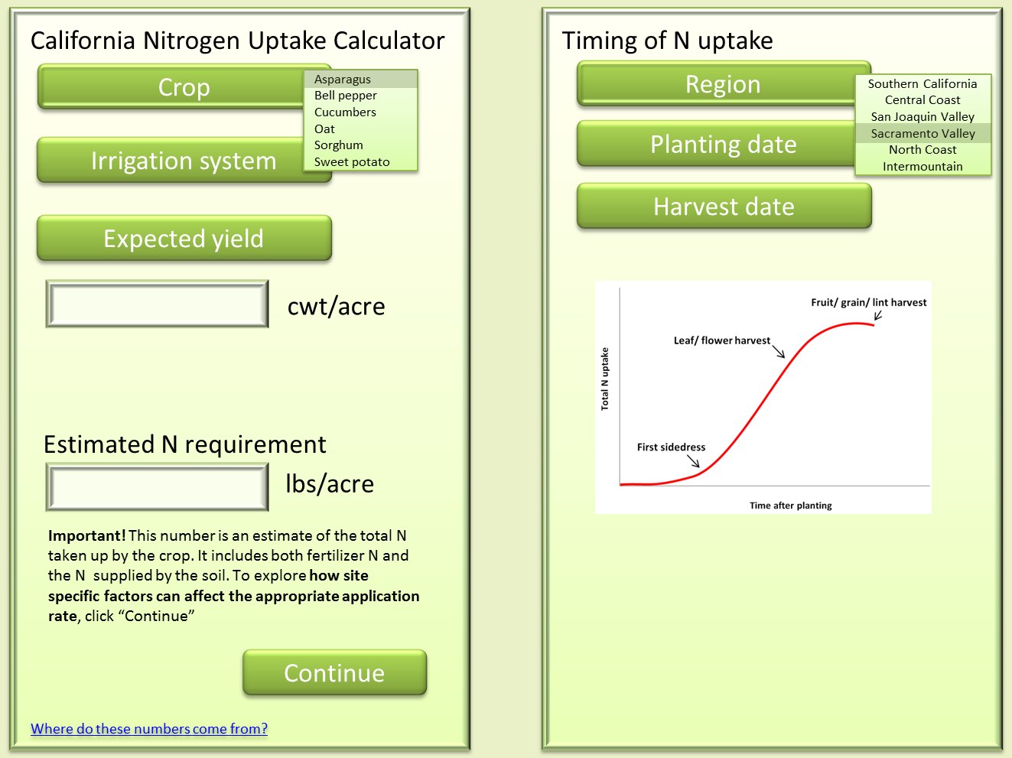

**Figure 1.** Example format of a simple N calculator, based on expected yield, data for crop N uptake, N removed at harvest and efficiency of the irrigation type.

Task 3: Develop an N budget tool taking into account site-specific factors

Users will be able to enter site-specific information, such as pre-fertilization soil nitrate test results, soil type, growing season (e.g. winter or summer) and location (Figure 2).

The calculator will then determine the effects of these factors on N fertilizer requirement and risk of leaching. The data currently available from California does not allow calculating accurate and robust site-specific N budgets. For this reason, the N budget tool will be designed as an educational tool that shall help users better understand the factors affecting N use efficiency and how these factors interact. However, the design of the tool shall allow incorporating new research results in the future, in order to gradually improve the accuracy of the calculations over time.

A major focus of the N budget tool shall be on the interaction between irrigation and N management. An effort will be made to visualize these interactions.

Examples of questions that may be addressed with the N budget tool are: (i) depth of irrigation water infiltration and movement of nitrate in different soil types, (ii) risk of nitrate losses with a single irrigation as a function of soil type, rooting depth and amount of water added, or (iii) effect of soil type on N mineralization potential.

The proposed N calculator and the N budget tool will complement existing dynamic decision support tools such as CropManage which use daily weather data and other site-specific information, by providing the background information to better understand the results of these tools.

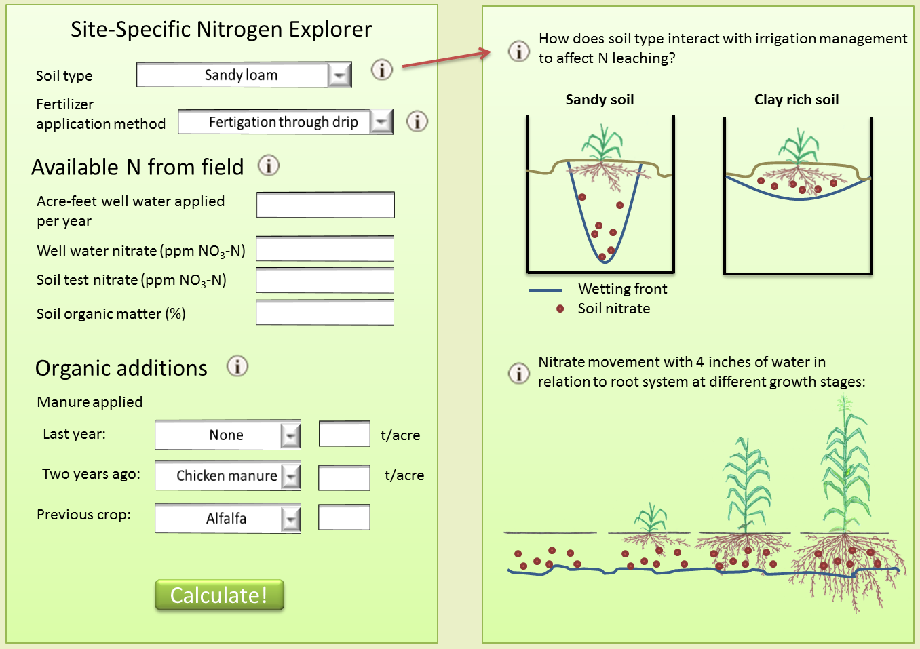

**Figure 2.** Example of how an educational tool can allow users to interactively explore the effects of different factors on site-specific N management, using a calculator-style page with accompanying visualizations.

Task 4: Write final report. The final report will be written and submitted in June 2018.

**F. Project Management, Evaluation, and Outreach**

**1. Management**

Daniel Geisseler will supervise the creation of the principles of efficient nutrient management and N calculator. Patricia Lazicki, who is currently writing fertilization guidelines for FREP project 15-0231, will summarize the principles of efficient N management and help compile literature data for the N calculator. A junior specialist will be hired to help with the web design of the N calculator.

**2. Evaluation**

Use of the web pages will be monitored using Google-Analytics. Since January 2015, the guidelines have generated on average more than 400 page views per month. We expect that the number of users will increase by 20% annually. We will present the guidelines at different of meetings and conferences. We expect to reach at least 150 people with presentations through 06/30/2018. We will use feedback from the audience and users to increase the usefulness of the site and improve its content. A short questionnaire will be prepared that can be handed out at meetings, together with a stamped return envelope.

Furthermore, users visiting the website will be asked to provide a feedback. Users will be asked to answer a few questions about the website (e.g. user-friendliness, quality of content, possible improvements), which can then be sent to us by email with the click of a button.

**3. Outreach**

The entire project is an outreach activity. All three parts of the proposed project are also ideally suited for presentations at field days, grower meetings and conferences. We expect to present the results of this project at four or more events during the second half of the project.

**G. Budget Narrative**

*Salaries*

Assistant Specialist

Under the supervision of D. Geisseler, Patricia Lazicki, an assistant specialist, will summarize principles of N, P and K fertilization and help create the corresponding webpage.

Patricia Lazicki, is currently writing guidelines for FREP project 15-0231. After completion of this project in summer 2017, she will work on the proposed project. We request a 0.5 FTE salary for Patricia from 07/01/2017 to 06/30/2018. The annual full-time salary for Patricia is expected to be $ 64,920 in fiscal year 2016/17 and to increase by 3% for fiscal year 2017/18. Therefore, we request $ 33,434 for fiscal year 2017/18. For the entire fiscal year, the requested salary will cover 0.5 FTE.

Junior Specialist

Salary for a junior specialist is requested. Under the supervision of D. Geisseler, the junior specialist will create the online N calculator including the educational tool. The junior specialist will have a 0.5 FTE appointment during the entire project. A full-time salary for a junior specialist is expected to be $ 49,500 in fiscal year 2016/17 and to increase by 3% for 2017/18. Therefore, we request $ 12,375 and $ 25,493 for fiscal years 2016/17 and 2017/18, respectively.

*Benefits*

It is anticipated that the composite benefit rate for both employed will be 38.1% during fiscal year 2016/17 and increase to 39.2% for fiscal year 2017/18. Thus, the total benefits for both employees will be $ 4,715 and $ 23,099 for fiscal years 2016/17 and 2017/18, respectively.

*Supplies*

No funding for supplies is requested.

*Equipment*

No equipment is required.

*Travel*

We request a total of $ 550 to support travel to attend local grower meetings and conferences (e.g. FREP Conference or California Plant and Soil Conference) to present the results of this project during fiscal year 2017/18. Our calculation is based on the rental fee for a sedan from UC Davis Fleet Service ($ 0.078 per mile, plus $ 50 per day) and on the assumption that travel will include a trip to Woodland (approximately 24 miles roundtrip) one trip to Stockton (approximately 120 miles roundtrip), and two overnight trips to Fresno (approximately 370 miles). We also request funding for accommodation, for a total of two nights in a hotel ($ 90 per night).

*Indirect Costs: (Accounted for in the “Other Expenses” line)*

Based on an agreement between CDSA and UC, the calculation of indirect costs is based on 10% of MTDC for fiscal year 2016/17 and 15% of MTDC for fiscal year 2017/18, which for the current project results in a total overhead cost of $ 1,709 and 12,383 for fiscal years 2016/17 and 2017/18, respectively.

**I. Appendices**

**1. Project Leader**

Resume and list of recent publications from

* Daniel Geisseler
* Patrizia Lazicki

**2. Letter of support from collaborators and supporters**

* Casey Creamer, Southern San Joaquin Valley MPEP Committee

**3. Literature cited**

California Department of Food and Agriculture, 2015. California Agricultural Statistics Review 2014-2015. Available online at: <https://www.cdfa.ca.gov/statistics/PDFs/2015Report.pdf>

Geisseler, D. Miyao, G., 2016. Soil testing for P and K has value for annual crops. California Agriculture 70, 152-159. Available online at: <http://ucanr.edu/repositoryfiles/ca2016a0007-161908.pdf>

Lazicki, P.A., Geisseler, D. Soil nitrate testing for site-specific nitrogen management in irrigated annual crops. Accepted for publication in California Agriculture**.**